ATM Transaction Dashboard
This Power BI dashboard provides a comprehensive overview of ATM transactions, costs, and revenues across different regions. The dashboard is designed to help stakeholders understand the performance, costs, and trends in ATM operations.

Dashboard Overview

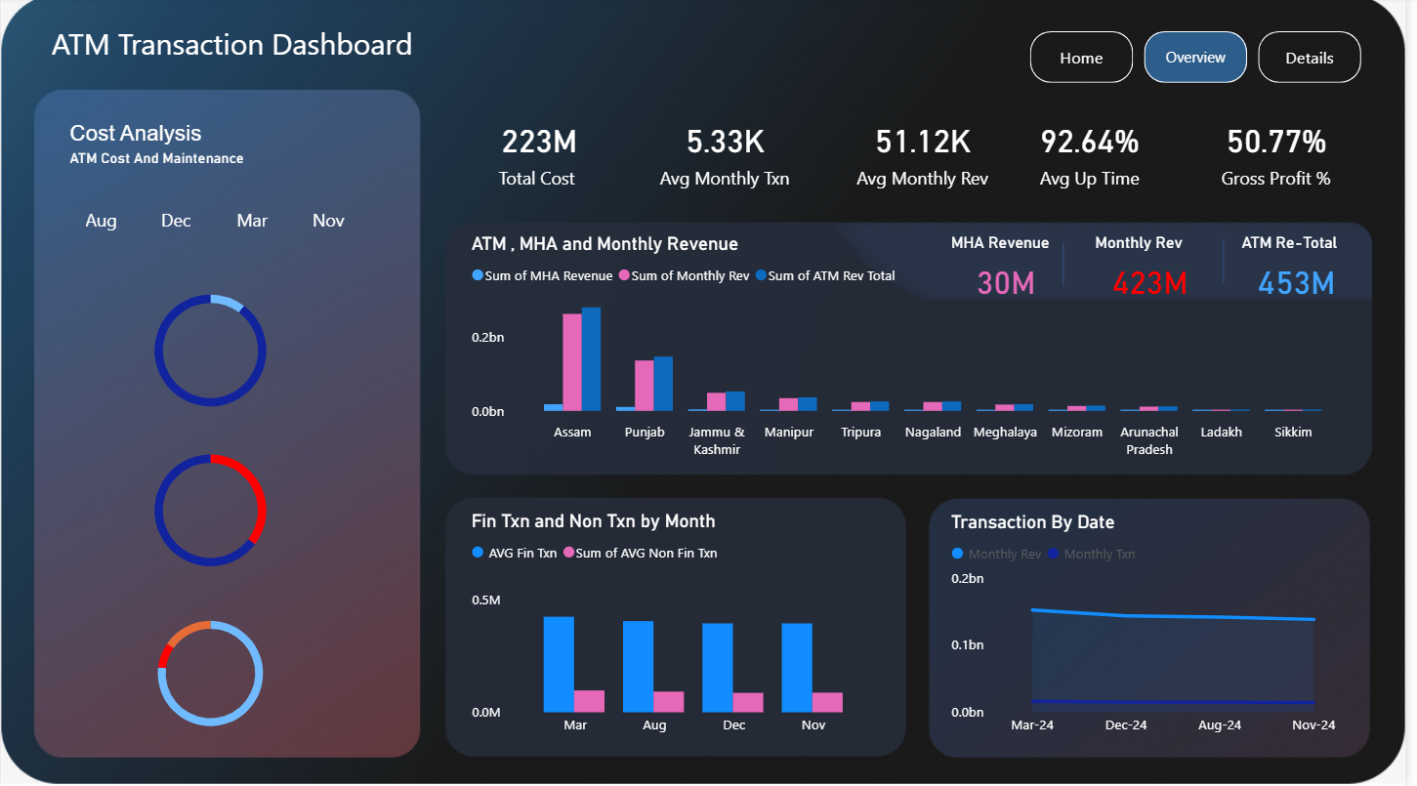

Cost Analysis (ATM Cost and Maintenance)
This section provides a breakdown of ATM maintenance costs. The costs are categorized and visualized using pie charts for the selected month (August). The categories include:
- CRA: Cash Replenishment Agency
- ATM AMC: ATM Annual Maintenance Contract
- Site Maintenance: Maintenance of the ATM site
- Spare Replacement: Replacement of ATM spare parts
- UPS AMC: Uninterruptible Power Supply Annual Maintenance Contract
- VSAT AMC: Very Small Aperture Terminal Annual Maintenance Contract

Key Metrics
- Total Cost: 296M
- Average Total Transactions (TXN): 178.89M
- Gross Profit Percentage: 59.6%
- Average Uptime: 91.9%
- Average EBILL: 2.21K

Revenue Analysis (ATM, MHA, and Monthly Revenue)
This section highlights the revenue generated from ATMs, MHA (Ministry of Home Affairs), and overall monthly revenue across various regions. The regions analyzed include:
- Assam
- Punjab
- Jammu & Kashmir
- Manipur
- Tripura
- Nagaland
- Meghalaya
- Mizoram
- Arunachal Pradesh
- Ladakh
- Sikkim

Financial Transactions (Fin Txn) and Non-Financial Transactions (Non-Fin Txn) by Month
This section compares the number of financial transactions to non-financial transactions across different months:
- March
- December
- August
- November

Transactions by Date
This line chart shows the trend of total transactions over time, specifically highlighting the months:
- March 2024
- May 2024
- July 2024
- September 2024
- November 2024

How the Dashboard Was Created

Data Collection
Data was collected from various sources including ATM transaction logs, maintenance records, and financial reports. The data was cleaned and prepared for analysis using data preprocessing techniques.

Visualization
- Power BI: The primary tool used for creating this dashboard is Power BI.
- Charts Used:
  - Pie Charts: For visualizing the cost breakdown in the Cost Analysis section.
  - Bar Charts: For comparing revenue across regions and transaction types by month.
  - Line Chart: For showing the trend in transactions over time.

Insights Derived
- Cost Efficiency: By breaking down the costs into specific categories, stakeholders can identify areas where cost-saving measures can be implemented.
- Revenue Streams: Understanding the revenue contributions from different regions helps in strategizing regional focus and improving profitability.
- Transaction Trends: Monitoring the trends in financial and non-financial transactions can help in predicting future transaction volumes and preparing accordingly.
- Performance Metrics: Key performance metrics such as average uptime and gross profit percentage provide a quick snapshot of the overall efficiency and profitability of ATM operations.

Importance of These Insights
- Operational Efficiency: Identifying cost drivers and optimizing maintenance costs can significantly enhance operational efficiency.
- Strategic Planning: Revenue insights assist in making informed decisions about resource allocation and marketing strategies.
- Predictive Maintenance: Trends in transaction data can help in predictive maintenance of ATMs, ensuring higher uptime and better customer service.
- Financial Performance: Key metrics help in assessing the financial health of the ATM network, guiding decisions to improve profitability.

Dashboard Image

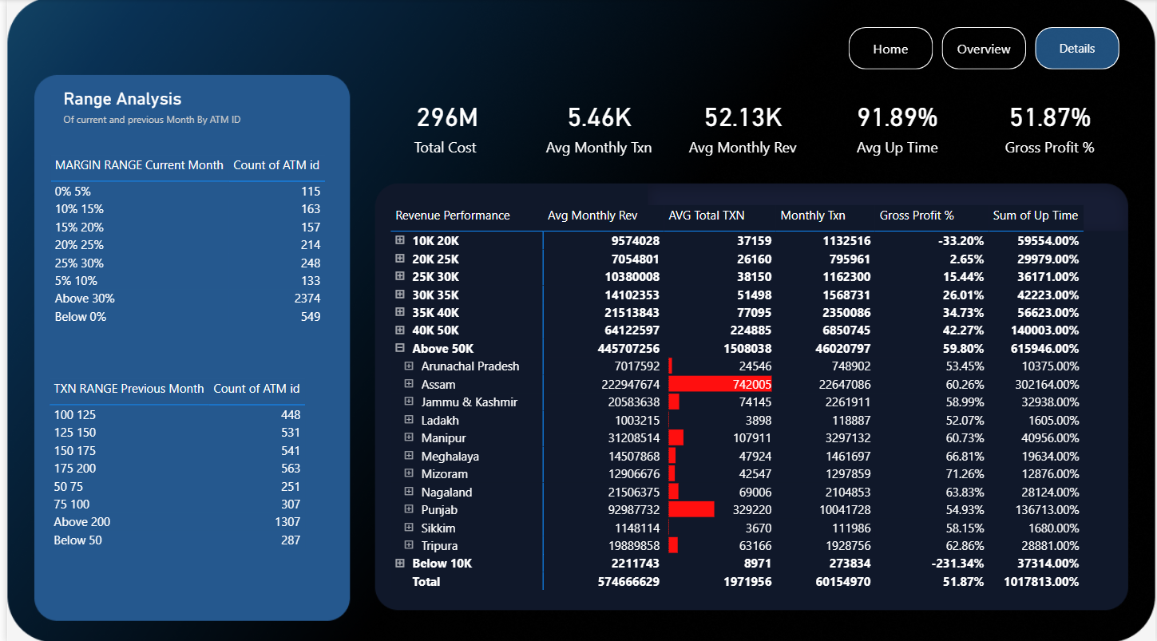

Cost Analysis (ATM Cost and Maintenance)
This section provides a breakdown of ATM maintenance costs. The costs are categorized and visualized using pie charts for the selected month (August). The categories include:
- CRA: Cash Replenishment Agency
- ATM AMC: ATM Annual Maintenance Contract
- Site Maintenance: Maintenance of the ATM site
- Spare Replacement: Replacement of ATM spare parts
- UPS AMC: Uninterruptible Power Supply Annual Maintenance Contract
- VSAT AMC: Very Small Aperture Terminal Annual Maintenance Contract

Key Metrics
- Total Cost: 296M
- Average Total Transactions (TXN): 178.89M
- Gross Profit Percentage: 59.6%
- Average Uptime: 91.9%
- Average EBILL: 2.21K

Revenue Analysis (ATM, MHA, and Monthly Revenue)
This section highlights the revenue generated from ATMs, MHA (Ministry of Home Affairs), and overall monthly revenue across various regions. The regions analyzed include:
- Assam
- Punjab
- Jammu & Kashmir
- Manipur
- Tripura
- Nagaland
- Meghalaya
- Mizoram
- Arunachal Pradesh
- Ladakh
- Sikkim

Financial Transactions (Fin Txn) and Non-Financial Transactions (Non-Fin Txn) by Month
This section compares the number of financial transactions to non-financial transactions across different months:
- March
- December
- August
- November

Transactions by Date
This line chart shows the trend of total transactions over time, specifically highlighting the months:
- March 2024
- May 2024
- July 2024
- September 2024
- November 2024

Detailed Analysis

Dashboard Image

Range Analysis (Current and Previous Month by ATM ID)
This section provides an analysis of ATM performance by margin and transaction ranges for the current and previous month:
- MARGIN RANGE Current Month:
  - 0% - 5%: 29 ATMs
  - 10% - 15%: 40 ATMs
  - 15% - 20%: 49 ATMs
  - 20% - 25%: 66 ATMs
  - 25% - 30%: 75 ATMs
  - Above 30%: 2137 ATMs
  - Below 0%: 332 ATMs
- TXN RANGE Previous Month:
  - 100 - 125: 216 ATMs
  - 125 - 150: 271 ATMs
  - 150 - 175: 306 ATMs
  - 175 - 200: 320 ATMs
  - 50 - 75: 128 ATMs
  - Above 200: 1207 ATMs
  - Below 50: 166 ATMs

Key Metrics
- Total Cost: 74M
- Average Total Transactions (TXN): 179.19M
- Gross Profit Percentage: 59.2%
- Average Uptime: 93.0%
- Average EBILL: 2.27K

Detail Analysis (By State and Revenue Performance)
This section provides a detailed breakdown of revenue performance by state, categorized by rent, monthly revenue, gross profit percentage, average uptime, average total transactions, and EBILL:
- Below 10K:
  - Arunachal Pradesh: Rent - 7200, Monthly Rev - 5448, Gross Profit % - 698.0%, Avg Up Time - 40.0%, AVG Total TXN - 24.00, EBILL - 5000
  - Assam: Rent - 17900, Monthly Rev - 47131, Gross Profit % - 402.0%, Avg Up Time - 50.6%, AVG Total TXN - 19.33, EBILL - 27183
  - Jammu & Kashmir: Rent - 82350, Monthly Rev - 387601, Gross Profit % - 202.3%, Avg Up Time - 93.7%, AVG Total TXN - 21.51, EBILL - 168722
  - Ladakh: Rent - 14810, Monthly Rev - 43225, Gross Profit % - 273.0%, Avg Up Time - 94.4%, AVG Total TXN - 25.00, EBILL - 17500
  - Manipur: Rent - 34000, Monthly Rev - 4262, Gross Profit % - 3002.9%, Avg Up Time - 32.2%, AVG Total TXN - 8.67, EBILL - 19378
  - Meghalaya: Rent - 9830, Monthly Rev - 427, Gross Profit % - 888.5%, Avg Up Time - 100.0%, AVG Total TXN - 20.00, EBILL - 19378
  - Nagaland: Rent - 427, Monthly Rev - 888.5, Gross Profit % - 156.7%, Avg Up Time - 87.6%, AVG Total TXN - 20.00, EBILL - 20000
  - Punjab: Rent - 3500, Monthly Rev - 62036, Gross Profit % - 157.6%, Avg Up Time - 87.6%, AVG Total TXN - 31.25, EBILL - 20000
  - Sikkim: Rent - 9571, Monthly Rev - 9471, Gross Profit % - 131.8%, Avg Up Time - 97.1%, AVG Total TXN - 20.00, EBILL - 7500
- Above 50K:
  - Rent - 8554184, Monthly Rev - 10860860, Gross Profit % - 63.7%, Avg Up Time - 93.9%, AVG Total TXN - 228.80, EBILL - 3667469
- 40K - 50K:
  - Rent - 1725300, Monthly Rev - 16525629, Gross Profit % - 63.9%, Avg Up Time - 93.3%, AVG Total TXN - 151.16, EBILL - 478317
- 35K - 40K:
  - Rent - 615065, Monthly Rev - 5587999, Gross Profit % - 64.0%, Avg Up Time - 93.4%, AVG Total TXN - 132.87, EBILL - 163459
- 30K - 35K:
  - Rent - 429000, Monthly Rev - 3427112, Gross Profit % - 64.1%, Avg Up Time - 93.5%, AVG Total TXN - 111.26, EBILL - 245703
- 25K - 30K:
  - Rent - 284739, Monthly Rev - 2476059, Gross Profit % - 64.2%, Avg Up Time - 93.6%, AVG Total TXN - 95.00, EBILL - 200000
- 20K - 25K:
  - Rent - 247570, Monthly Rev - 1747372, Gross Profit % - 64.3%, Avg Up Time - 93.7%, AVG Total TXN - 79.16, EBILL - 172923
- 10K - 20K:
  - Rent - 355820, Monthly Rev - 2435212, Gross Profit % - 64.4%, Avg Up Time - 93.8%, AVG Total TXN - 56.99, EBILL - 385808

How the Dashboard Was Created

Data Collection
Data was collected from various sources including ATM transaction logs, maintenance records, and financial reports. The data was cleaned and prepared for analysis using data preprocessing techniques.

Visualization
- Power BI: The primary tool used for creating this dashboard is Power BI.
- Charts Used:
  - Pie Charts: For visualizing the cost breakdown in the Cost Analysis section.
  - Bar Charts: For comparing revenue across regions and transaction types by month.
  - Line Chart: For showing the trend in transactions over time.
  - Detailed Tables: For detailed analysis of revenue performance by state and transaction ranges.

Insights Derived
- Cost Efficiency: By breaking down the costs into specific categories, stakeholders can identify areas where cost-saving measures can be implemented.
- Revenue Streams: Understanding the revenue contributions from different regions helps in strategizing regional focus and improving profitability.
- Transaction Trends: Monitoring the trends in financial and non-financial transactions can help in predicting future transaction volumes and preparing accordingly.
- Performance Metrics: Key performance metrics
such as average uptime and gross profit percentage provide a quick snapshot of the overall efficiency and profitability of ATM operations.

Importance of These Insights
- Operational Efficiency: Identifying cost drivers and optimizing maintenance costs can significantly enhance operational efficiency.
- Strategic Planning: Revenue insights assist in making informed decisions about resource allocation and marketing strategies.
- Predictive Maintenance: Trends in transaction data can help in predictive maintenance of ATMs, ensuring higher uptime and better customer service.
- Financial Performance: Key metrics help in assessing the financial health of the ATM network, guiding decisions to improve profitability.

